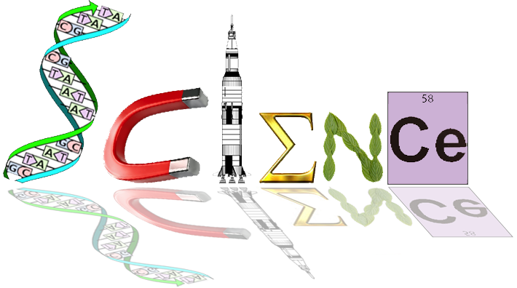

**Yr. 12 Human Biology**

**Extended Response**

**Task 7**

**Mary** is a new mum who was vaccinated as a child by her parents but as an adult has decided that Vaccination is dangerous after hearing celebrities from the US claim that the vaccines cause Autism, and reading Anti Vaxxer Blogs. Mary is also a Blogger who likes to update her readers daily about her thoughts and feelings towards motherhood.

Mary’s child is about to turn 6 weeks old, which in Australia is the time to receive immunisations against Whooping cough, Tetanus, Gastro and Diphtheria.

Mary has written a piece where she expresses her dislike of vaccines whilst making many unfounded claims that she has repeated after hearing them from unproven sources.

In this post it becomes very clear that Mary does not know how Vaccines work and the responses are overwhelmingly negative, which only put Mary further off.

Mary’s friend **Kate** also has a young child, who has Leukaemia, a cancer of the immune system. This makes her child very susceptible to acquiring infectious disease. Kate worries that she will not be able to spend time with her friend, as her child will not be vaccinated.

**Your Task:**

You are to write a response to Mary’s Blog from Kate’s perspective, with the aim to educate and inform in a non-hostile manner, in order to convince Mary about the benefits of Vaccine. Be sure to include:

* What vaccines actually are and the different types
* How they work in triggering an immune response and achieving immunity
* The benefits for her child
* How she would be benefiting Kate’s child via Herd Immunity
* A discussion about the Ethical, moral and controversial aspects of the issue

**NOTES PAGE: (unmarked)**

________________________________________________________________________________________________________________________________________________________________________________________________________________________________________________________________________________________________________________________________________________________________________________________________________________________________________________________________________________________________________________________________________________________________________________________________________________________________________________________________________________________________________________________________________________________________________________________________________________________________________________________________________________________________________________________________________________________________________________________________________________________________________________________________________________________________________________________________________________________________________________________________________________________________________________________________________________________________________________________________________________________________________________________________________________________________________________________________________________________________________________________________________________________________________________________________________________________________________________________________________________________________________________________________________________________________________________________________________________________________________________________________________________________________________________________________________________________________________________________________________________________________________________________________________________________________________________________________________________________________________________________________________________________________________________________________________________________________________________________________________________________________________________________________________________________________________________________________________________________________________________________________________________